
Web: | www.anbobio.com  www.dijibio.com
Order: | order@dijibio.com
Tel: | (86) 519 8805 0026

Web: | www.abtbio.com
Order: | order@abtbio.com
Tel: | 1-408-747-0189

LHR2A Antibody [#C10028]

----------------------------------------------------------------------------------------------------------------------------------------------------------------

Catalog Number: C10028
Concentration: 1mg/ml
Swiss-Prot No.: O00534
Other Names: Loss of heterozygosity 11 chromosomal region 2 gene A protein, Breast cancer suppressor candidate 1, BCSC-1, LOH11CR2A, BCSC1
Storage/Stability: Store at -20℃/1 year
Form of Antibody: Rabbit IgG in phosphate buffered saline (without Mg²⁺ and Ca²⁺), pH 7.4, 150mM NaCl, 0.02% sodium azide and 50% glycerol.
Immunogen: The antiserum was produced against synthesized peptide derived from Internal of human LHR2A.
Purification: The antibody was affinity-purified from rabbit antiserum by affinity-chromatography using epitope-specific immunogen.
Specificity: LHR2A antibody detects endogenous levels of total LHR2A protein.
Reactivity: Human
Applications: WB: 1:500~1:3000 ELISA: 1:20000
References:
Martin E.S., Proc. Natl. Acad. Sci. U.S.A. 100:11517-11522(2003).
The MGC Project Team, Genome Res. 14:2121-2127(2004).
Monaco C., Genomics 46:217-222(1997).

----------------------------------------------------------------------------------------------------------------------------------------------------------------
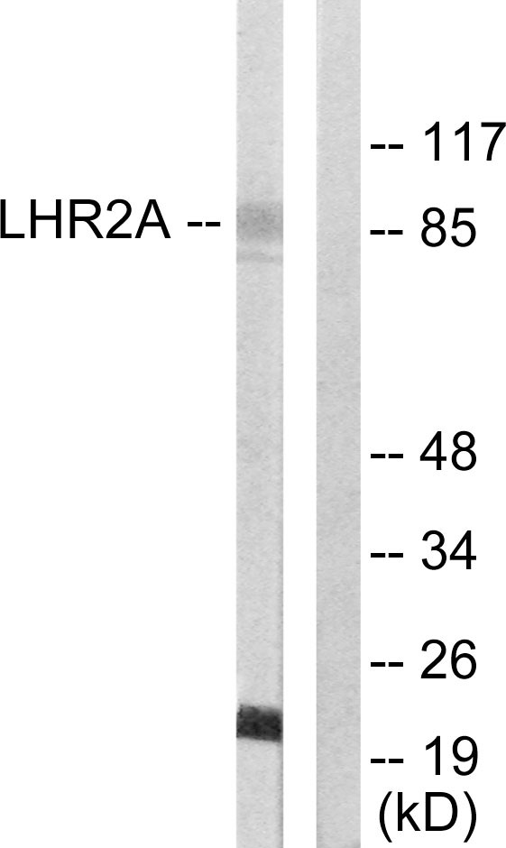
Peptide | - | +

Western blot analysis of extracts from 293 cells, using LHR2A antibody.

