
Web: | www.anbobio.com  www.dijibio.com
Order: | order@dijibio.com
Tel: | (86) 519 8805 0026
Web: | www.assaybiotech.com
Order: | order@assaybiotech.com
Tel: | 1-877-883-7988 (Free in USA)
Web: | www.anbobio.com
Order: | order@anbobio.com
Tel: | 4000-234-432
Web: | www.anbobio.com
Order: | order@anbobio.com
Tel: | 4000-234-432

ALS2CR13 Antibody [#C14464]

----------------------------------------------------------------------------------------------------------------------------------------------------------------

Catalog Number: C14464
Concentration: 1mg/ml
Swiss-Prot No.: Q6P1L5
Other Names: Amyotrophic lateral sclerosis 2 chromosomal region candidate gene 13 protein; Protein FAM117B; FAM117B
Storage/Stability: Store at -20℃/1 year
Form of Antibody: Rabbit IgG in phosphate buffered saline (without Mg²⁺ and Ca²⁺), pH 7.4, 150mM NaCl, 0.02% sodium azide and 50% glycerol.
Immunogen: The antiserum was produced against synthesized peptide derived from C-terminal of human ALS2CR13.
Purification: The antibody was affinity-purified from rabbit antiserum by affinity-chromatography using epitope-specific immunogen.
Specificity: ALS2CR13 antibody detects endogenous levels of total ALS2CR13 protein.
Reactivity: Human (Identities = 100%, Positives = 100%);
Mouse (Identities = 93%, Positives = 93%)
Applications: WB: 1:500~1:3000 ELISA: 1:5000
References:
Hillier L.W., Nature 434:724-731(2005).
Hadano S., Nat. Genet. 29:166-173(2001).
Ota T., Nat. Genet. 36:40-45(2004).

----------------------------------------------------------------------------------------------------------------------------------------------------------------
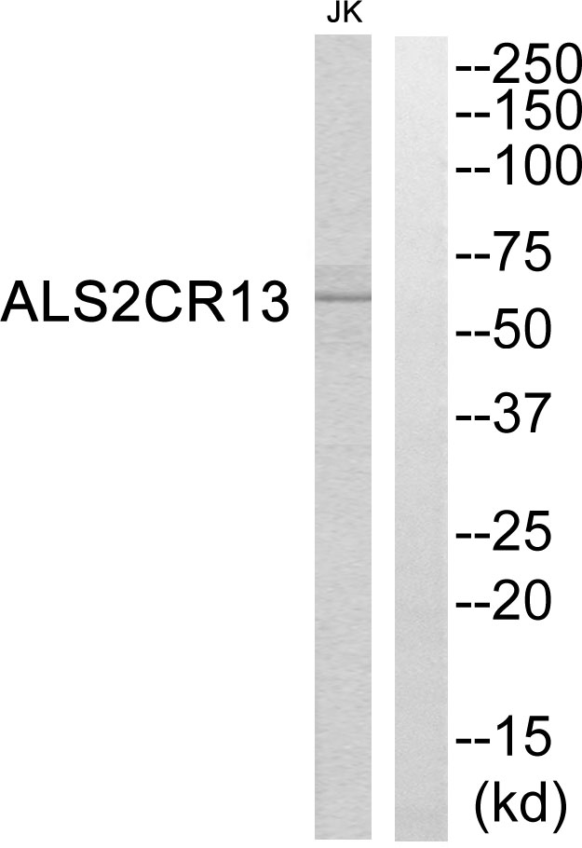
Peptide | - | +

Western blot analysis of extracts from Jurkat cells, using ALS2CR13 antibody.

